**Lab 02: R fundamentals 2**

**Olivia Dinkelacker**

**Q1 (2 pts.):** Show the R code you used to create vec_2.

vec_2 = vec_1 == 3

**Q2 (2 pts.):** Give two reasons why determining which elements in vec_1 have value 3 by visual inspection is a bad idea.

If the data set is very big it will return too many numbers to have a good overview and you can easily overlook values. Furthermore, you cannot clearly see the position of the element and if you rerun the code, numbers could be different due to random selection.

**Q3 (1 pt.):** Why didn’t you always get the same count of 3 entries each time?

The sample function randomly generates numbers every time we run the code

**Q4 (3 pts.):** Considering the different vectors generated each time, explain why using a logical test is a safe way to select entries with a value of 3.

Because it is an easy binary code that filters out all values with 3 and “discards” all values that are not 3 by returning FALSE. Since 3 is set equal to TRUE ( ==) it is safe that all elements that are considered TRUE (exactly 3) are returned.

**Q5 (5 pts.):** Explain why performing logical ‘by hand’ subsetting is very very bad practice. You may want consider re-usability of code, working with different sized data sets, and sharing code with collaborators. Your answer should cite at least *two* reasons why ‘by hand’ subsetting is bad.

Since the code always selects random numbers, different results are returned. This is also complicated when you want to share codes and results or even findings with collaborators but due to the randomness, they cannot retrace them or results cannot be compared. The codes are universal but the results differ.

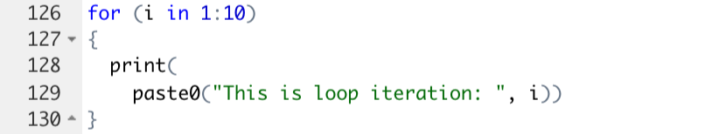**Q6 (3 pts.):** Provide the code for your modified loop.

**Q7 (2 pts.):** Provide the code for the modified loop that executes n times. It needs to be a self contained example. I should be able to set the value of n and then run your loop on my computer.

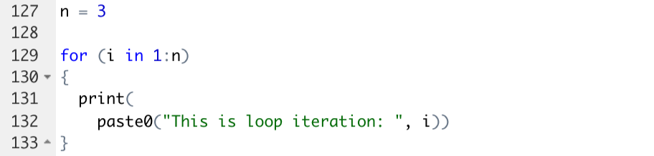

**Q8 (4 pts.):** Provide the code you used to create the n, vec_1, and the loop. As always, it should run as a stand-alone example in a fresh R session on my computer.

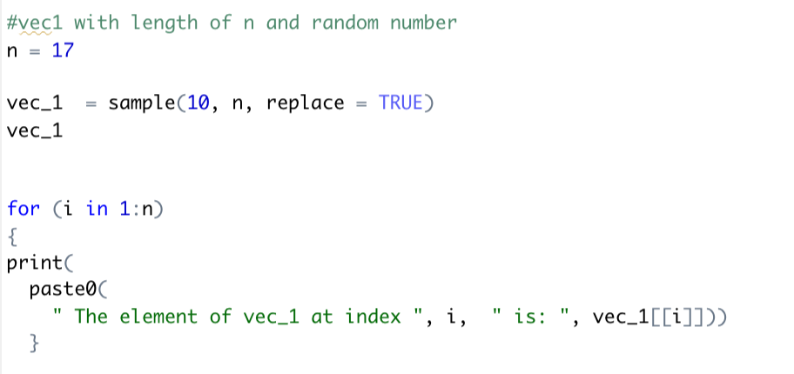

**Q9 (10 pts.):** Provide the code you used to build your function.

